Control Engineering

Handout – Online Laboratory 9

Name: *Colda Andreea Ariana*

Group: *30332*

 and 

Using the cascade structure, design two controllers to reject a step disturbance in the inner loop and a ramp disturbance in the outer loop. Compare the performance with a classical control loop, designed to reject a ramp disturbance (Figure 9.2).

HR(s)

Hf1(s)

Hf2(s)

-

w

y

**Figure 9.2**. Classical negative feedback control structure

Tuning steps:

* design the Hr2(s) controller for the process Hf2(s) (using the magnitude optimum criterion because the inner loop should reject step disturbances)

*Add controller here*

*3.4884 (s+1.667)*

*Hr2(s) = ----------------*

*s*

* compute the Hf(s) process using equation (9.1)
* design the Hr1(s) controller for Hf(s) (using the symmetrical optimum criterion because the outer loop should reject ramp disturbances)

*Add controller here*

*20.032 (s+0.4808) (s+0.02)*

*Hr1 = --------------------------*

*s^2*

* test the obtained controllers using Simulink
* add a step disturbance at the output of the inner loop and a ramp disturbance at the output of the outer loop
* design another controller using the symmetrical optimum process, this time for Hf1(s)* Hf2(s) - see Fig. 9.2

*Add controller here*

*1.0912 (s+0.2252) (s+0.02)*

*Hr = --------------------------*

*s^2*

* validate the controller using Simulink (add a ramp disturbance to the output of the process)
* compare the two tuning strategies

*Add the comparison here (plots from Simulink)*

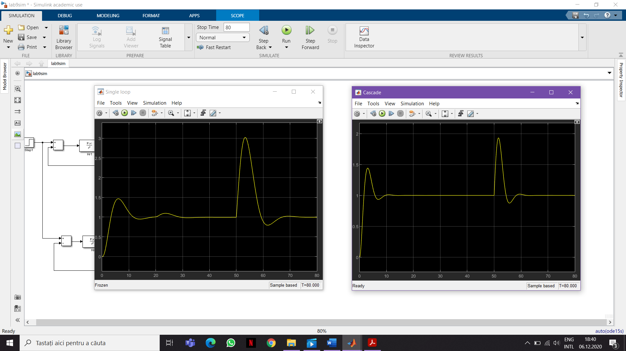



The overshoot is a little bit higher for the cascade control structure and the settling time is 10 sec which is very fast, but for the single loop control structure the settling time is almost 20 sec, double the time. When the step disturbance occurs, the cascade system manages to reject it in time completely, but in the other case, for the single loop system, the step disturbances affect the output. The ramp disturbance makes the amplitude for the cascade system to increase to almost 2, but it is settling in about 10 seconds, the disturbances were completely rejected. On the single control loop the ramp disturbances increase the amplitude to 3 and the settling time is almost 20 sec.